

A bilingual first-time mum companion: Umubyeyi

BSE

Raissa IRUTINGABO

Mission Capstone

Supervisor

2026

DECLARATION

This Proposal Project is my original work, unless stated, and all external sources have been referenced or cited in my document. This work has not been presented for award of degree or for any similar purpose in any other university

Signature………………………… July 10th 2026…………………..

Raissa IRUTINGABO
CERTIFICATION

The undersigned certifies that he has read and hereby recommended for acceptance of African Leadership University a report entitled ………..

Signature……………………… Date………………………….
Prof/Dr./Mrs./Miss/Mr. Name of the Supervisor
Faculty,
Bachelor of Software Engineering,
ALU

DEDICATION AND ACKNOWLEDGEMENT

I thank my supervisor, Samiratu Ntoshi, for the guidance and feedback throughout the project. I also thank African Leadership University, my family, and everyone who supported the development and testing of this project.

Abstract

Umubyeyi is a bilingual system that supports the emotional well-being of first-time mothers in Rwanda during the first six months after birth. It works in English and Kinyarwanda and focuses on emotional concerns such as sadness, anxiety, loneliness, guilt, exhaustion, and feeling overwhelmed.
The final system combines several project-trained machine-learning components with an external large language model. A language detector, a bilingual intent classifier, and a character n-gram TF-IDF retriever route and ground every message against a source-attributed, WHO-derived knowledge bank of 14 postpartum topics. Wellbeing answers are generated by Groq, a hosted large language model, with a project-trained, fine-tuned BLOOMZ-560m generator as a documented fallback layer, and the reviewed retrieved passage as the final, always-available fallback. Deterministic, model-independent safety rules for crisis, clinical, and off-topic messages run before generation is ever reached. Beyond the chat, the system includes a validated EPDS-10 postpartum wellness self-assessment, a guided screening-risk check-in with real-time SHAP explainability, and a client-side progress dashboard.
Evaluation was carried out at the level of each component, because classification, retrieval, generation, and safety routing are different tasks with different failure modes. The bilingual intent classifier was compared against six other candidate models, the two screening-risk classifiers were evaluated on an untouched participant test set, the fine-tuned generator was evaluated against its own unfine-tuned base model using ROUGE-L and lexical diversity, and an automated test suite verified safety routing and multi-turn conversation behaviour end to end.

TABLE OF CONTENTS

LIST OF TBLES

Table 1: Project scope
Table 2: Overview of existing systems
Table 3: Summary of reviewed literature
Table 4: Strengths and weaknesses of existing systems
Table 5: Main system components
Table 6: Development tools
Table 7: Unit testing results
Table 8: Intent classifier comparison (validation set)
Table 9: Bilingual retrieval results
Table 10: Screening-risk classifier results
Table 11: Generator evaluation metrics
Table 12: End-to-end system trace
Table 13: Key findings and design decisions

LIST OF FIGURES
Figure 1: Proposed model diagram
Figure 2: Technical system architecture
Figure 3: Request lifecycle flowchart
Figure 4: Use case diagram
Figure 5: Class diagram
Figure 6: Sequence diagram
Figure 7: Confusion matrix, selected bilingual intent classifier (Extra Trees)
Figure 8: Model comparison chart
Figure 9: BLOOMZ-560m fine-tuning training vs validation loss curve
Figure 10: Full 46-predictor screening model, validation comparison
Figure 11: Reduced 15-input guided check-in model, validation comparison

LIST OF ACRONYMS AND ABBREVIATIONS

Acronym | Full Form
API | Application Programming Interface
AUC | Area Under the Curve
BLEU | Bilingual Evaluation Understudy
CHW | Community Health Worker
FLAN | Fine-tuned Language Net
JSON | JavaScript Object Notation
LLM | Large Language Model
NLP | Natural Language Processing
NER | Named Entity Recognition
RAG | Retrieval-Augmented Generation
ROUGE | Recall-Oriented Understudy for Gisting Evaluation
SDLC | Software Development Life Cycle
SVM | Support Vector Machine
TF-IDF | Term Frequency–Inverse Document Frequency
WHO | World Health Organization

CHAPTER ONE: INTRODUCTION

1.1 Introduction and Background
Umubyeyi is a bilingual system that provides emotional well-being support, a validated wellness self-assessment, and screening-risk feedback to first-time mothers in Rwanda during the first six months after giving birth. The name comes from the Kinyarwanda word for mother. That choice is deliberate: this is a system built from the context of Rwandan motherhood outwards, not a general-purpose chatbot retrofitted with local language.
The system receives a message from a mother, checks whether it involves a safety concern or falls outside scope, detects the language, and retrieves the most relevant reviewed postpartum topic. The reply itself is generated by Groq, a hosted large language model that answers from its own general knowledge of postpartum emotional wellbeing rather than being limited to the project's reviewed passages, so a repeated question can be answered differently each time. The project's own fine-tuned generator (BLOOMZ-560m, trained with LoRA on real supportive-conversation data) is kept as a real, working fallback layer, and the reviewed passage itself is the final fallback if neither generator is available. Alongside the chat, a mother can take a validated EPDS-10 self-assessment, complete a guided screening-risk check-in that returns a real-time SHAP explanation of its own result, and see her own trends on a client-side progress dashboard.
The project is deliberately limited to emotional well-being and screening-level risk estimation. It does not offer medical advice, does not answer questions about infant fever, feeding difficulties, or clinical symptoms, and does not diagnose postpartum depression, only an elevated- or not-elevated-risk estimate with an accompanying explanation. Clinical questions are referred to a health worker, and crisis messages are referred to Rwanda's emergency line. This boundary is not a weakness in the system; it is the most important design decision the project makes.

1.2 Problem Statement
The period following childbirth is one of the most emotionally demanding transitions a person can experience, and it is also one of the least supported by digital health tools, particularly in Rwanda and in Kinyarwanda. The World Health Organization (2022) describes postnatal care as a period where mothers need not only medical monitoring but also reassurance, information, and emotional support. Yet the majority of existing maternal health tools are built for English-speaking users in high-income countries, focus on clinical tracking rather than emotional experience, and assume reliable internet access and high digital literacy.
Perinatal mental health is a recognised global concern. According to the World Health Organization (n.d.), depression and other mental health conditions can affect mothers after childbirth at higher rates in developing countries than in high-income settings. In Rwanda, this challenge is compounded by cultural expectations that a mother should feel only joy after a healthy delivery, which makes it harder for women to express distress or seek support. A first-time mother who is overwhelmed, lonely, or struggling with guilt is unlikely to find a tool that speaks to her experience, and is even less likely to find one in Kinyarwanda.
The specific problem this project addresses is the absence of a simple, locally controlled, bilingual system that can provide grounded postpartum emotional support in English and Kinyarwanda while maintaining clear and safe boundaries. Fluency alone is not sufficient for this context. The system must know what it does not know, must refer clinical and crisis cases, and must be transparent about where machine-learning models end and where validated human-written content begins.

1.3 Main Objective
The main objective of this project is to design, implement, and evaluate a bilingual system that provides grounded emotional well-being support, a validated postpartum wellness self-assessment, and explainable screening-risk feedback for first-time mothers in Rwanda, combining local machine-learning components, an external large language model, and deterministic safety rules.

1.4 Specific Objectives
The following five objectives guided the implementation:

1. Build a source-attributed bilingual postpartum emotional well-being knowledge base and use it for retrieval, routing, and citation in both English and Kinyarwanda.
2. Train local machine-learning components for language detection and bilingual intent classification, and compare their performance against multiple candidate algorithms.
3. Implement a hybrid generation cascade in which a hosted large language model (Groq) is the primary wellbeing-answer generator, with a project fine-tuned generator (BLOOMZ-560m, LoRA) and direct retrieval as real, evaluated fallback layers.
4. Train and evaluate two screening-risk classifiers on a licensed postpartum depression dataset (a full research model and a reduced guided-check-in model), and provide real-time SHAP explainability for the check-in result.
5. Implement a validated EPDS-10 postpartum wellness self-assessment and a client-side progress dashboard that tracks a mother's own results over time, entirely on-device.
6. Implement deterministic safety rules for crisis, clinical, and off-topic inputs that fire before any model is consulted.
7. Deploy and evaluate the system end to end across classification, retrieval, generation, and safety-routing behaviour.

1.5 Research Questions
The project was guided by the following questions:

Primary: How effectively can a hybrid architecture, combining local machine-learning classification and retrieval, a licensed-dataset screening-risk model, and an external large language model for generation, provide grounded, safe, bilingual postpartum emotional support and explainable risk screening for first-time mothers in Rwanda?

1. How accurately did local classical classifiers perform on bilingual intent classification and on postpartum screening-risk prediction, given the size of the available datasets?
2. Did the project's own fine-tuned generator (BLOOMZ-560m) provide reliable wellbeing responses across a full multi-turn conversation, compared with a general-purpose hosted large language model?
3. What generation quality, measured by ROUGE-L and lexical diversity (Distinct-2), did the fine-tuned generator achieve relative to its own unfine-tuned base model?
4. Did the end-to-end system correctly and deterministically route emotional, clinical, crisis, and off-topic messages in both languages, and did the guided check-in produce an accurate, explainable screening-risk estimate?

1.6 Project Scope

In Scope | Out of Scope
English and Kinyarwanda emotional support conversation | Medical diagnosis of any condition (the system estimates screening risk, not diagnosis)
First-time mothers, 0-6 months postpartum | Emergency medical treatment or clinical advice
Emotional concerns: sadness, anxiety, loneliness, guilt, exhaustion, overwhelm | Baby-care clinical questions (fever, feeding, bleeding, medication)
A validated EPDS-10 wellness self-assessment and a guided, explainable screening-risk check-in | French language support (deferred from original proposal)
Crisis referral to Rwanda 114 | Pregnancy or antenatal care topics
Clinical referral to a health worker | General-purpose chatbot conversation outside the defined scope
Off-topic redirection; a client-side progress dashboard of a mother's own results | Any server-side storage of raw conversation or check-in content

1.7 Significance and Justification

This project was significant for three reasons. First, it addressed a documented and unmet need: no bilingual English-Kinyarwanda postpartum emotional support tool existed prior to this work. The WHO (2022) and the global perinatal mental health literature (World Health Organization, n.d.) confirmed that postpartum emotional well-being required dedicated attention, and that Rwanda's first-time mothers were a population with specific unmet needs in this area.
Second, the project demonstrated a practical middle ground between a fully local system and an open-ended commercial chatbot: every safety-critical decision, crisis detection, clinical referral, off-topic redirection, remains fully local and deterministic, independent of any model, while generation quality benefits from a general-purpose hosted language model that the project's own small fine-tuned model could not match in practice. This has practical significance beyond Rwanda: in any low-resource-language health context, keeping safety decisions local while allowing generation to draw on a larger external model is a reusable template.
Third, several independent technical contributions came out of the project beyond the chatbot itself: the 14-topic, source-attributed bilingual knowledge base used for retrieval and safety routing; two screening-risk classifiers trained and evaluated on a licensed postpartum depression dataset, with a real-time, model-agnostic SHAP explanation computed from each mother's own answers; and the integration of the EPDS-10, a real validated clinical instrument, into a gamified, crisis-aware self-assessment flow. None of these existed before this capstone and each could support future work independently of the chatbot built around them.

CHAPTER TWO: LITERATURE REVIEW

2.1 Introduction
This chapter reviewed the technical and contextual work that informed the design of Umubyeyi. Sources were identified through Google Scholar, PubMed, the ACL Anthology, and arXiv. The review covered maternal health chatbots, postpartum mental health support tools, natural language processing for low-resource languages, and retrieval-augmented generation. The chapter is organised around the standard literature review structure: historical background, overview of existing systems, detailed review of related work, a summary table, and a strengths-and-weaknesses analysis leading to the identified research gap.

2.2 Historical Background of the Research Topic
Conversational systems for health support have evolved across three broad generations. The first generation, active from the 1960s through the early 2000s, consisted of rule-based systems using handwritten decision trees and pattern-matching scripts. ELIZA, developed at MIT in the 1960s, demonstrated that even simple reflective responses could feel meaningful to users discussing personal concerns, a finding that proved influential in the later development of mental health chatbots (Weizenbaum, 1966, as cited in Ojo et al., 2023).
The second generation, spanning roughly 2010–2020, introduced machine learning to intent classification and named entity recognition. Commercial platforms such as Dialogflow and IBM Watson Assistant made it possible to build domain-specific chatbots without training models from scratch, at the cost of dependency on proprietary infrastructure and the requirement for major-language training data. Maternal health applications such as MumCare (Maduwantha & Vithana, 2021) emerged in this period, using Dialogflow for intent routing.
The third and current generation is defined by large pre-trained language models, GPT, BERT, FLAN-T5, and their descendants, fine-tuned for specific tasks or prompted for zero-shot performance. Retrieval-augmented generation, introduced by Lewis et al. (2020), represented an important architectural innovation within this generation: by grounding generation in retrieved content, RAG reduced hallucination risk without abandoning the flexibility of neural generation. Umubyeyi began from this generation with a fully local generator to avoid any commercial API dependency, motivated by both the low-resource Kinyarwanda constraint and the safety requirements of a health-facing system. During development, however, the project's own fine-tuned model proved unreliable across a full multi-turn conversation, which motivated a hybrid design described in Chapter Three: a hosted large language model as the primary generator, with the local model retained as a real fallback layer, and deterministic safety rules kept fully independent of either generator so that the safety concern that motivated the original local-only choice is still met.
Maternal health as a domain for conversational AI received growing attention from 2020 onwards, accelerated by the COVID-19 pandemic's disruption of in-person postnatal care. However, as the following sections show, this attention remained concentrated on English-speaking, high-income populations, leaving the postpartum emotional wellbeing needs of Kinyarwanda-speaking mothers in Rwanda unaddressed.

2.3 Overview of Existing Systems
Ten systems and reviews were examined across the maternal health chatbot and perinatal mental health AI literature. They fell into three thematic groups: pregnancy-focused chatbots using neural NLP, postpartum rule-based or SMS-based systems, and systematic reviews of AI in perinatal and African maternal health.

System | Technical Approach | Focus and Key Limitation
PregBot (Bhaskar et al., 2024) | Random Forest + BERT + TensorFlow. Flask interface. | Pregnancy-focused; English NLP. Postpartum secondary. Kinyarwanda is not supported.
MumCare (Maduwantha & Vithana, 2021) | Dialogflow rule-based engine. React Native + Firebase. | Pregnancy only. Requires major-language training data. No postpartum content.
Rosie (Mane et al., 2023) | NLP Q&A with user feedback. NIH-funded. | Postpartum + infant care. English only. US context. 90%+ user intent to use.
Fourth Trimester Chatbots (Vatsa et al., 2026) | Rule-based fixed logic. Multidisciplinary team. | Postpartum and newborn. Cannot handle open-ended queries.
Mwana, Nigeria (PMC, 2025) | SMS-based predefined responses. No ML layer. | Breastfeeding support only. Lagos context. Very narrow scope.
Suharwardy et al. RCT (2023) | CBT-delivery chatbot. Randomised controlled trial. | Postpartum mental health only. No significant group difference at 6 weeks.
Kenya Digital Health RCT (PLOS Med, 2025) | Digital platform with guided content. Cluster RCT. | Positive postpartum outcomes in Kenya. Not Kinyarwanda. Not chatbot-based.
AI in African Maternity (Bolarinwa et al., 2024) | Systematic review. | Confirms language as primary barrier to AI uptake in SSA maternal health.
Conversational AI & Perinatal MH (Frontiers, 2026) | Systematic review of LLM approaches. | Warns against autonomous chatbots in vulnerable populations.
AI Agent & Maternal Wellbeing (Frontiers GWH, 2023) | Mixed-methods mHealth evaluation. | Questions clinical efficacy of autonomous AI agents for maternal support.

2.4 Review of Related Work
Three technical themes from the literature directly shaped the design of Umubyeyi.
The first was the dominance of neural NLP and its incompatibility with Kinyarwanda. Every reviewed system that performed open-ended language understanding PregBot, Rosie, MumCare used Dialogflow, BERT, or GPT-based models requiring large labelled corpora in the target language. Ojo et al. (2023) demonstrated that large language models performed unevenly across African languages. This finding was corroborated within the project by the cross-lingual degradation test described in Section 5.1.1.
The second theme was the safety risk of generative AI in vulnerable populations. The Frontiers in Psychiatry (2026) review explicitly warned against autonomous generative chatbots for perinatal users, citing the 2023 suspension of the NEDA eating disorder chatbot as evidence of the potential for harm. The Frontiers in Global Women's Health (2023) review similarly questioned the clinical efficacy of autonomous AI agents for maternal mental health. Umubyeyi's response to this warning is architectural rather than a refusal to use generative models at all: crisis, clinical, and off-topic detection run as deterministic, keyword-and-pattern logic before any generator, local or hosted, is ever consulted, so no generative model is ever in a position to mishandle a safety-critical message.
The third theme was the temporal and emotional gap in existing coverage. Every reviewed system either focused on pregnancy rather than the postpartum period, or addressed clinical tracking rather than emotional experience. The WHO (2022) defined postnatal care as including emotional reassurance and support, a dimension that none of the reviewed chatbot systems treated as its primary purpose.

2.4.1 Summary of Reviewed Literature

Source | Method | Key Finding for Umubyeyi Design
Bhaskar et al. (2024) | Random Forest + BERT + NLP | Demonstrates ML pipeline; English-only; motivates non-neural Kinyarwanda alternative
Maduwantha & Vithana (2021) | Dialogflow + React Native | Rule-based requires major-language data; motivates retrieval over intent-based approaches
Mane et al. (2023) | NLP Q&A + user feedback | 90%+ intent to use; English/US context proves gap for Kinyarwanda/Rwanda
Lewis et al. (2020) | Retrieval-augmented generation (RAG) | RAG grounds generation in retrieved content; reduces hallucination risk in health contexts
Chung et al. (2022) | Instruction-tuned FLAN-T5 | Instruction fine-tuning suits small domain-specific datasets; selected for English generator
Ojo et al. (2023) | LLM evaluation across African languages | LLMs perform unevenly on African languages; motivates keeping Kinyarwanda generation behind a validated fallback rather than trusting open-ended output alone
Pedregosa et al. (2011) | scikit-learn ML library | Standard classical ML tooling; used for language detection and intent routing
Frontiers Psychiatry (2026) | Systematic review of LLMs in perinatal care | Recommends deterministic safety handling before generative models are consulted
Frontiers GWH (2023) | Mixed-methods mHealth evaluation | Questions clinical efficacy of autonomous agents; supports retrieval-grounded design
Wolf et al. (2020) | Hugging Face Transformers | Standard transformer tooling; used for FLAN-T5 fine-tuning and inference

2.5 Strengths and Weaknesses of Existing Systems

Strengths of Existing Systems | Weaknesses Motivating Umubyeyi
Rosie (Mane et al., 2023): rigorous multidisciplinary development; 90%+ user intent to use; covers postpartum and infant topics. | English-only; US-centric; does not address emotional wellbeing as primary focus.
Fourth Trimester Chatbots (Vatsa et al., 2026): rule-based design avoids hallucination; covers both mother and newborn. | Cannot handle open-ended queries; no Kinyarwanda; fixed topic set.
Mwana (PMC, 2025): SMS delivery appropriate for low-bandwidth SSA contexts. | Covers breastfeeding only; no emotional support; no Kinyarwanda.
PregBot (Bhaskar et al., 2024): strong ML pipeline combining classical and transformer models. | Pregnancy-focused; NLP inapplicable to Kinyarwanda without labelled data.
Lewis et al. (2020) RAG framework: reduces hallucination by grounding generation. | Standard RAG implementations vary in how they balance local control and generation quality; Umubyeyi started fully local and moved to a hybrid design after its own local generator proved unreliable mid-conversation.

2.6 General Comments and Research Gap
Across all ten reviewed sources, the same gap appeared consistently: no system combined bilingual English-Kinyarwanda support, a focus on postpartum emotional wellbeing specifically, and deterministic safety handling kept fully independent of whichever model produces the reply. Umubyeyi was designed to sit precisely at this intersection. The evidence reviewed supported both the need and the architectural approach: the WHO (2022) confirmed the need; Ojo et al. (2023) supported keeping Kinyarwanda generation behind a validated fallback rather than trusting open-ended output in an under-resourced language; and the Frontiers in Psychiatry (2026) review mandated placing deterministic safety rules before any model in the pipeline, a requirement that held regardless of whether the generator ended up local or hosted.

CHAPTER THREE: SYSTEM ANALYSIS AND DESIGN

3.1 Introduction
This chapter describes the research design, datasets, requirements, proposed model, system architecture, UML diagrams, and development tools used in implementing Umubyeyi. The system followed the Spiral Development Life Cycle (Boehm, 1988), which proceeded in iterative cycles of planning, risk analysis, engineering, and evaluation. This SDLC model was chosen because the knowledge base content, the generation strategy, and the safety rules all required review and adjustment as the project progressed. The generation strategy in particular went through a real iteration: an early fully local design was replaced with the hybrid design described in this chapter after the project's own fine-tuned model proved unreliable mid-conversation in practice.

3.2 Research Design
The project followed a build-and-evaluate design, combining software engineering implementation with quantitative ML evaluation. Four distinct data sources were used, each for a different purpose: a source-attributed, WHO-derived bilingual postpartum knowledge bank for retrieval and safety-routing citation; a licensed postpartum depression dataset of 800 participant records for training and evaluating the two screening-risk classifiers, and for scoring the EPDS-10 self-assessment against its own item-level scoring key; an AMOD-derived, weak-labelled bilingual question set for training the intent classifier; and real supportive-conversation data (ESConv) for fine-tuning the project's own generator. The evaluation design was mixed-methods: quantitative classifier, retrieval, and generator metrics were complemented by an automated test suite that verified end-to-end safety routing and multi-turn conversation behaviour.

3.2.1 Dataset and Dataset Description
The runtime knowledge bank is stored as a JSON file containing 14 reviewed postpartum emotional wellbeing topics. Each record includes an id, topic label, source citation, English and Kinyarwanda passage text, and English and Kinyarwanda query variants used for retrieval matching. Every entry is sourced from World Health Organization postnatal and perinatal mental health guidance. Clinical, pregnancy, and baby-care items are excluded by design; those questions are referred to a health worker instead of being answered from this bank. The 14 topics span emotional themes including normal emotional changes, persistent sadness, anxiety and worry, sleep and fatigue, feeling overwhelmed, guilt and self-blame, irritability and anger, loss and grief, bonding and emotional connection, partner and family support, social support, seeking professional help, daily functioning, and urgent confusion or psychosis (the last routes directly to the crisis path).
This knowledge bank is used for two purposes: as the reviewed, always-available fallback answer if generation fails or is rejected by safety validation, and as the source of citations and routing categories for the deterministic safety layer. It remains an original contribution of this project distinct from the two other project datasets described below: a screening-risk dataset and an intent-classification dataset.
For the bilingual intent classifier, 596 deduplicated question pairs derived from the Amod/mental_health_counseling_conversations corpus were used, split 417 training, 89 validation, and 90 untouched test rows, with English and Kinyarwanda versions of the same question always kept in the same split. The labels are project-authored keyword weak labels rather than expert annotations, and the Kinyarwanda text is NLLB-200 machine translation rather than a human translation, both of which are stated explicitly as limitations in Chapter Six rather than presented as gold-standard data. For the screening-risk classifiers, the licensed Postpartum Depression Prediction dataset (Raisa & Kaiser, Mendeley Data v3, CC BY 4.0) supplied 800 participant records from Bangladesh, from which 46 predictors were used for a full research model and a reduced set of 15 predictors for a guided check-in model, with all concurrent EPDS and PHQ items, totals, and derived labels excluded to prevent target leakage.

3.2.1 Proposed Model Diagram

Figure1:Proposedmodeldiagram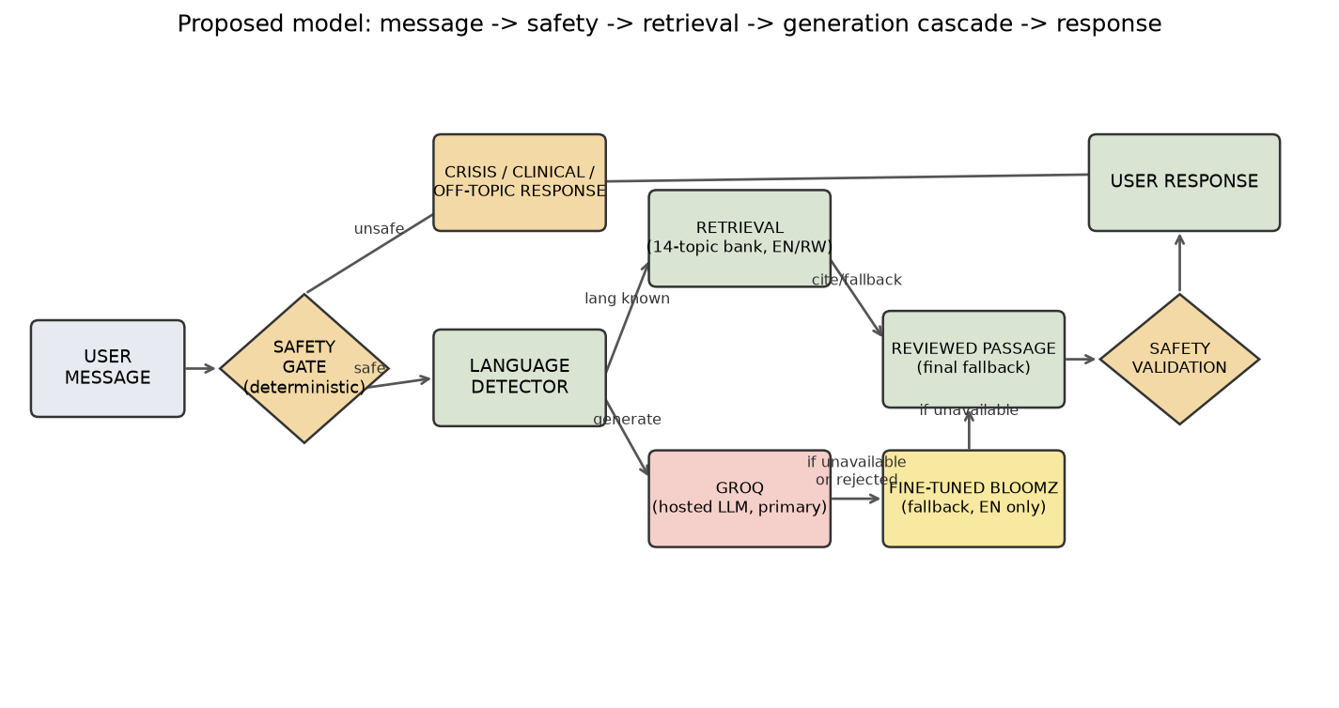

3.3 Functional and Non-Functional Requirements

Functional Requirements
The system was required to:

• Accept free-text messages in English or Kinyarwanda.
• Detect the input language automatically using a local classifier.
• Generate a wellbeing response using Groq as the primary generator, with the project's own fine-tuned BLOOMZ-560m model and direct retrieval as real fallback layers.
• Detect crisis messages deterministically and immediately return a Rwanda 114 referral.
• Refer clinical and baby-care questions to a health worker without providing clinical content.
• Redirect off-topic messages with a scope explanation.
• Offer a validated EPDS-10 self-assessment with per-item scoring and a crisis interception on self-harm items.
• Offer a guided screening-risk check-in that returns a non-diagnostic result with a real-time SHAP explanation of that specific result.
• Show a client-side progress dashboard of a mother's own EPDS, mood, and check-in trends.
• Store chat and mood history locally within the browser; store only anonymous, non-content analytics server-side, and only if a database is configured.

Non-Functional Requirements
• Every generated response must pass deterministic safety and content validation (length bounds, no unverifiable invented numbers) before it is shown; a response that fails validation must fall back to the next layer, ending in the reviewed, source-attributed passage, never a broken or empty reply.
• No message text or check-in answers may be stored server-side; only anonymous, non-content analytics (language, response mode, latency) may be stored, and only if a database is configured.
• The system must degrade safely through its full generation cascade, Groq, then the fine-tuned model, then optional local Ollama, then the reviewed retrieved passage, never returning a broken or empty reply.
• The interface must be accessible on a mobile browser without an app download.

3.4 System Architecture
Umubyeyi uses a hybrid retrieval-and-generation architecture with a strict separation between safety and generation. Language detection, retrieval, the bilingual intent classifier, the two screening-risk classifiers, and the SHAP explainer all run as project-trained or project-controlled components. Crisis, clinical, and off-topic detection are deterministic and run first, before any generator is consulted, regardless of which generator eventually answers. Generation itself is a cascade: Groq (a hosted large language model) is tried first, the project's own fine-tuned BLOOMZ-560m model is a real fallback, optional local Ollama is a further dev-only fallback, and the reviewed retrieved passage is the final, always-available fallback. Every response, whichever layer produced it, passes the same safety validation before being returned. The frontend is a Next.js/React single-page application; the backend is a set of Python functions deployed as Vercel serverless endpoints, mirrored locally by a small HTTP adapter for development. The architecture is illustrated in Figure 2.

Figure2:Technicalsystemarchitecturegit 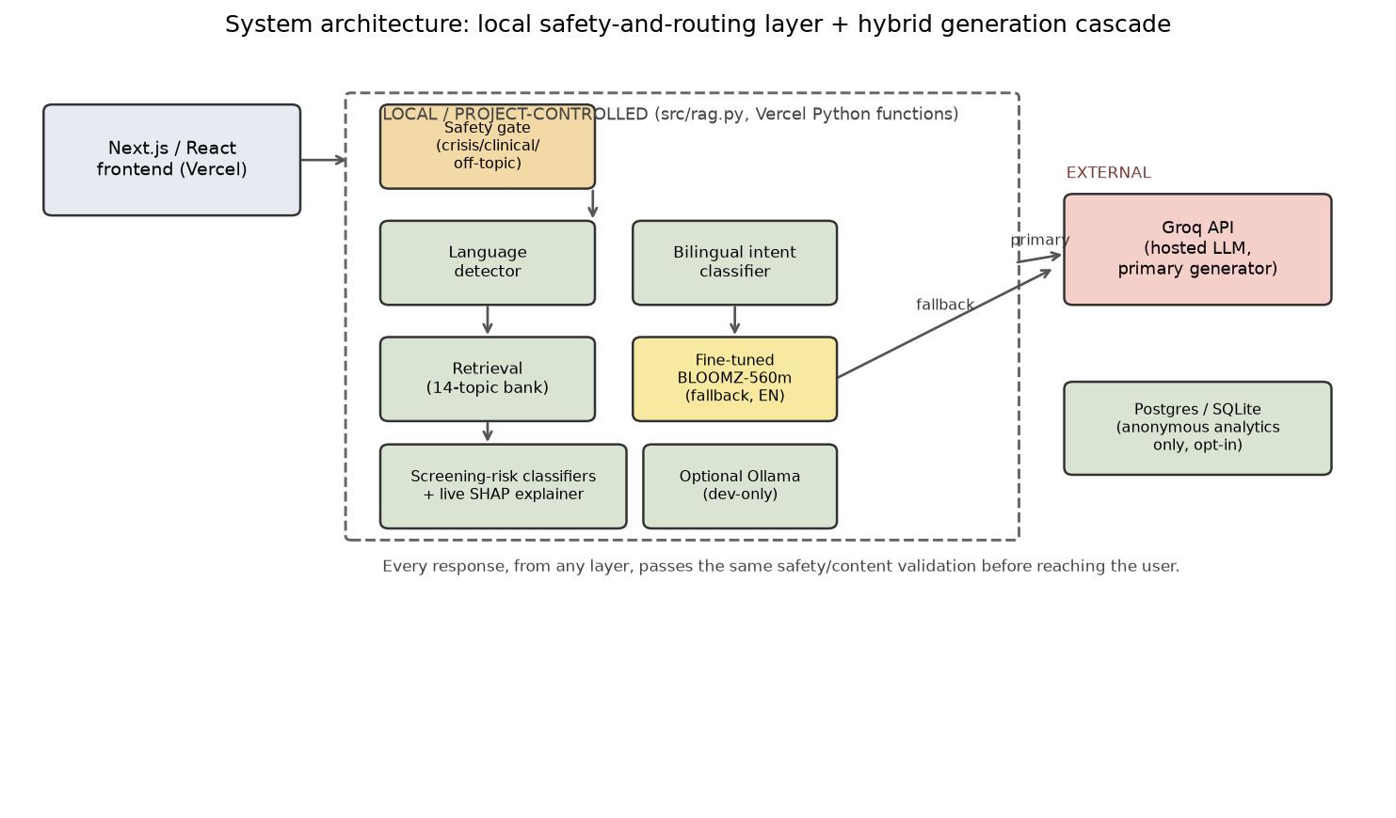

Table 5 lists the main system components:

Component | File / Location | Role
Frontend | app/, components/, lib/ (Next.js/React) | Chat interface, EPDS-10 flow, guided check-in, progress dashboard, self-care
Core pipeline | src/rag.py | Orchestrates the safety gate, language detector, retrieval, and the generation cascade
Language detector | models/lang_detector.joblib | Detects English or Kinyarwanda
Bilingual intent classifier | models/topic_classifier.joblib | Predicts emotional intent; maps to the 14 reviewed knowledge-bank topics
Knowledge bank | data/knowledge/postpartum_wellbeing.json | 14 reviewed, source-attributed bilingual postpartum topics
Primary generator | src/groq_generator.py (Groq API) | Hosted large language model; primary wellbeing-answer, greeting, and title generator
Fallback generator | models/umubyeyi-bloomz-lora/, src/finetuned_generator.py | Project fine-tuned BLOOMZ-560m (LoRA on ESConv); English-only fallback
Screening-risk classifiers | models/ (full + check-in pipelines) | Elevated-risk estimate from licensed postpartum depression data; not diagnosis
Explainability | src/explain.py | Real-time, model-agnostic SHAP explanation of the check-in result
EPDS-10 assessment | lib/epds.ts, components/EpdsAssessment.tsx | Validated postpartum wellness self-assessment with crisis interception
Progress dashboard | components/ProgressDashboard.tsx | Client-side trend view of EPDS, mood, and check-in history
Analytics (optional) | src/db.py | Anonymous, non-content session analytics; Postgres or local SQLite

3.5 UML Diagrams
The following diagrams describe the system structure and behaviour: the request lifecycle through the safety, retrieval, and generation cascade; a use case diagram covering the chat, EPDS-10, guided check-in, and progress dashboard flows; a class diagram of the core backend services; and a sequence diagram for one representative request.
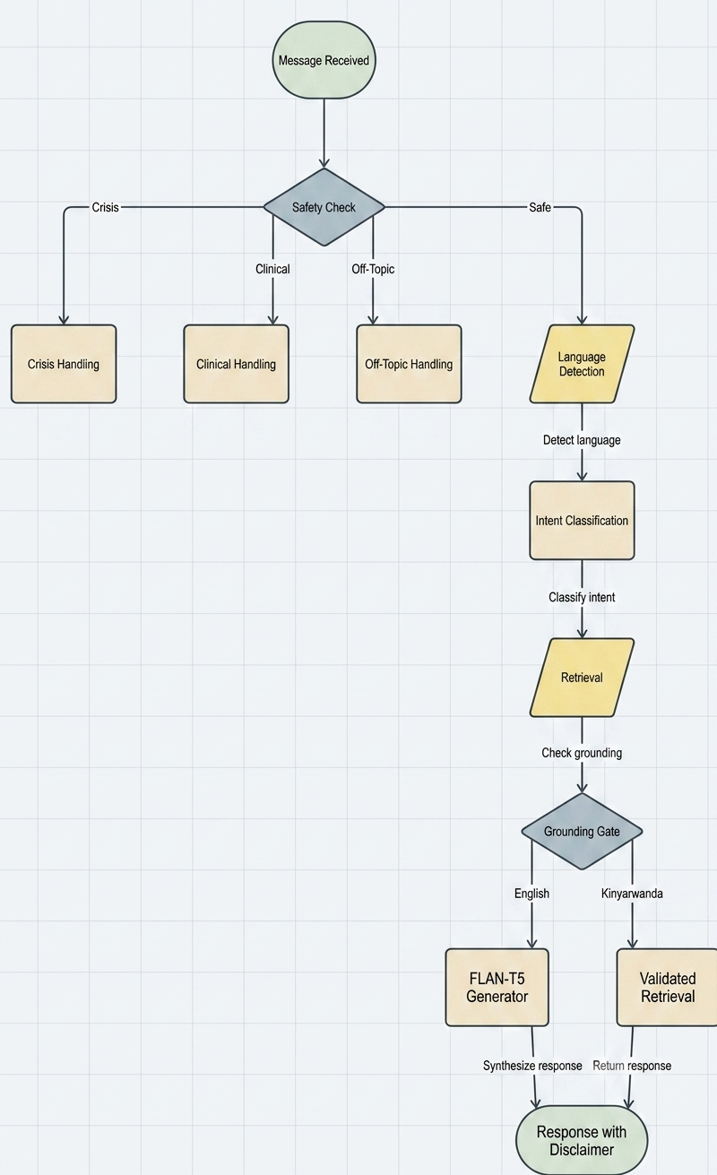
Figure 3: Request lifecycle flowchart

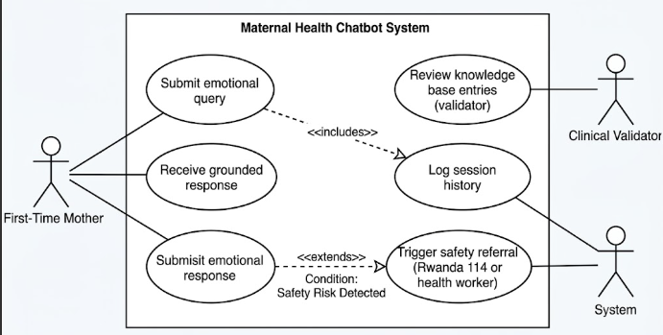

Figure 4: Use case diagram

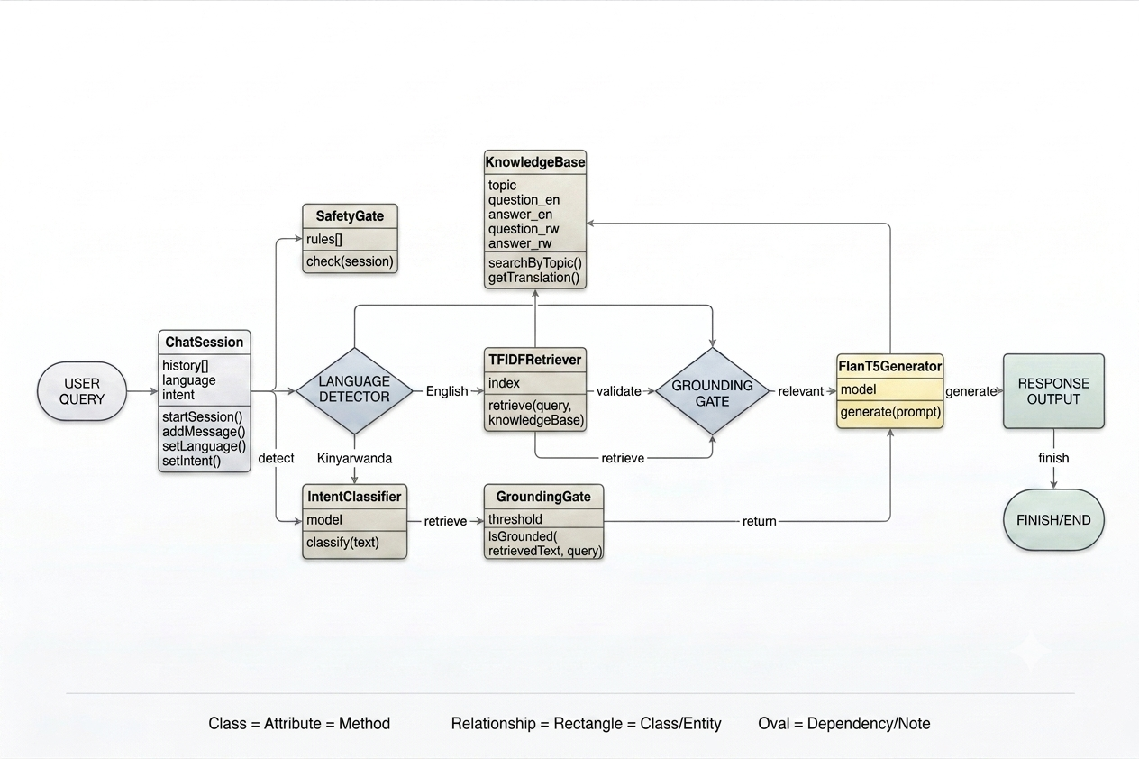

Figure 5: Class diagram
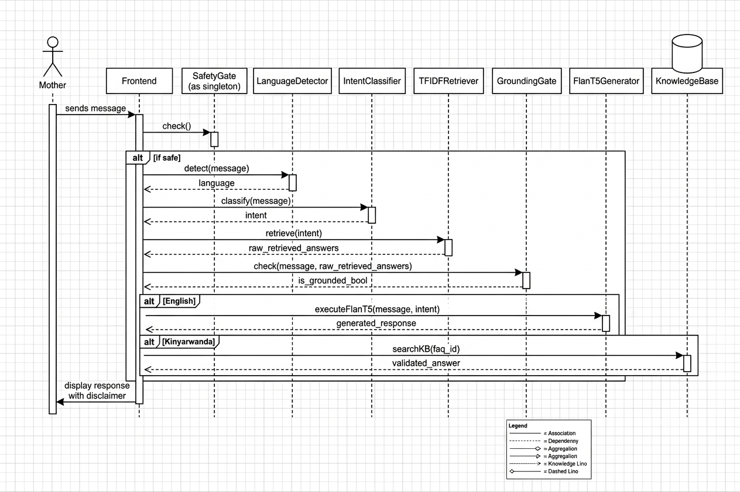
Figure 6: Sequence diagram

3.6 Development Tools
Table 6 lists the tools and libraries used in implementation:

Tool / Library | Role
Python 3.11-3.13 | Backend pipeline, classifiers, generator fine-tuning and inference
scikit-learn 1.9 | Language detector, bilingual intent classifier, and both screening-risk classifiers
Hugging Face Transformers, PEFT, Datasets | BLOOMZ-560m LoRA fine-tuning and local inference
bigscience/bloomz-560m | Pre-trained decoder-only base model, fine-tuned as the fallback generator
Groq API (llama-3.3-70b-versatile) | Primary wellbeing-answer, greeting, and title generator
SHAP | Real-time, model-agnostic explanation of the check-in risk classifier (local/Colab only)
TF-IDF (scikit-learn) | Character n-gram retrieval engine over the knowledge bank
Next.js 15 / React 19 / TypeScript | Web frontend, deployed on Vercel
Recharts | Progress-dashboard trend charts
Vercel (Python serverless functions) | Deployment for both the frontend and the backend API
Google Colab (T4 GPU) | Cloud GPU environment for BLOOMZ fine-tuning
pytest | Automated unit, integration, and HTTP-contract testing (80 tests)
pandas / NumPy | Data processing and evaluation analysis
PostgreSQL (Neon) / SQLite | Optional anonymous analytics storage
JSON | Knowledge bank storage format
GitHub / Vercel CI | Version control and deployment pipeline

CHAPTER 4: SYSTEM IMPLEMENTATION AND TESTING

4.1 Implementation and Coding

4.1.1 Introduction
This section describes the implemented system components and how they were assembled into a working pipeline. The focus is on the implementation decisions made during development rather than a repeat of the design rationale covered in Chapter Three. The core pipeline is implemented in src/rag.py, which orchestrates the safety gate, the language detector, retrieval, and the generation cascade in a fixed sequence, and exposes the same functional API to the Next.js frontend both locally and on the deployed Vercel build. The overall approach was to implement and test each component independently, with its own pytest module, before integrating them.

4.1.2 Description of Implementation Tools and Technology
The language detector was trained using scikit-learn's TfidfVectorizer with character n-gram features, which produced distinctive character sequence features for Kinyarwanda's agglutinative morphology. The trained model was serialised to models/lang_detector.joblib for inference and is checked first in the pipeline, since every downstream decision, retrieval, safety routing, and the choice of generator, depends on the detected language.
The bilingual intent classifier was trained on 596 deduplicated bilingual question pairs derived from the Amod/mental_health_counseling_conversations corpus (417 train, 89 validation, 90 untouched test rows), combining word- and character-level TF-IDF features. Seven candidates were compared: a dummy baseline, Complement Naive Bayes, Logistic Regression, a calibrated linear SVM, Random Forest, Extra Trees, and K-Nearest Neighbors, with results reported in Chapter Five. Extra Trees was selected and serialised to models/topic_classifier.joblib. At runtime its top-3 predicted intents are mapped to the 14 reviewed postpartum topics for routing and citation.
The retriever builds a same-language character n-gram TF-IDF index over the 14-topic knowledge bank, separately for English and Kinyarwanda, and scores candidate topics by cosine similarity. Its output supplies the reviewed passage used as the final fallback answer, and its top match supplies the citation and topic used by the deterministic safety and scope layer, independently of whether that specific message is ultimately answered by generation or by the passage itself.
Wellbeing answers are generated by a cascade rather than a single model. Groq, a hosted large language model (llama-3.3-70b-versatile), is tried first for both English and Kinyarwanda; it receives the current message and the last several real conversation turns, and answers from its own general postpartum-wellbeing knowledge rather than being constrained to the project's own passages. Its output passes a lightweight safety check (length bounds and a check against unverifiable invented numbers such as phone numbers or dosages) before use. If Groq is unavailable or its answer is rejected, the project's own fine-tuned generator is tried next: bigscience/bloomz-560m, fine-tuned with LoRA using the Hugging Face Transformers and PEFT libraries on real supportive-conversation data (ESConv), answering freely from its own fine-tuned weights, English only. An optional local Ollama model is a further development-only fallback. If every generation layer fails or is unavailable, the reviewed retrieved passage itself is returned, so the system never produces a broken or empty reply.
The safety gate uses deterministic keyword and pattern matching implemented in Python without any ML dependency, and it runs before any generator, local or hosted, is ever consulted. Crisis patterns (self-harm language, expressions of wanting to die) trigger an immediate return of the Rwanda 114 referral. Clinical and baby-care patterns (fever, bleeding, medication, feeding) trigger a health worker referral instead of any generated or retrieved clinical content. Off-topic patterns trigger a scope-clarification redirect. All safety response text is pre-written and reviewed before deployment; none of it is generated.

4.2 Graphical View of the Project

4.2.1 Screenshots with Description
The following screenshots illustrate the key features of the system that directly address the problem statement. Each feature corresponds to a functional requirement listed in Section 3.3.

Screenshot 1: 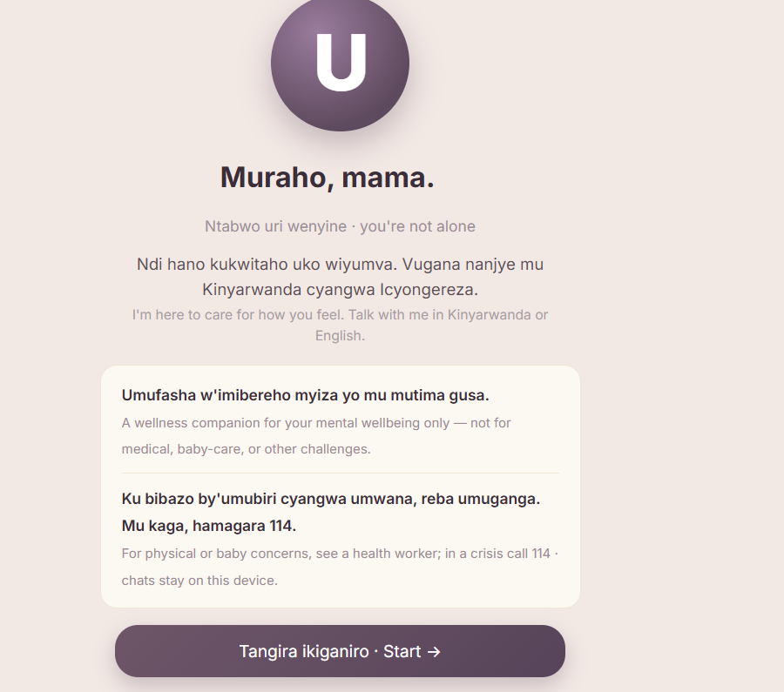

Screenshot 2: English emotional support response Description:
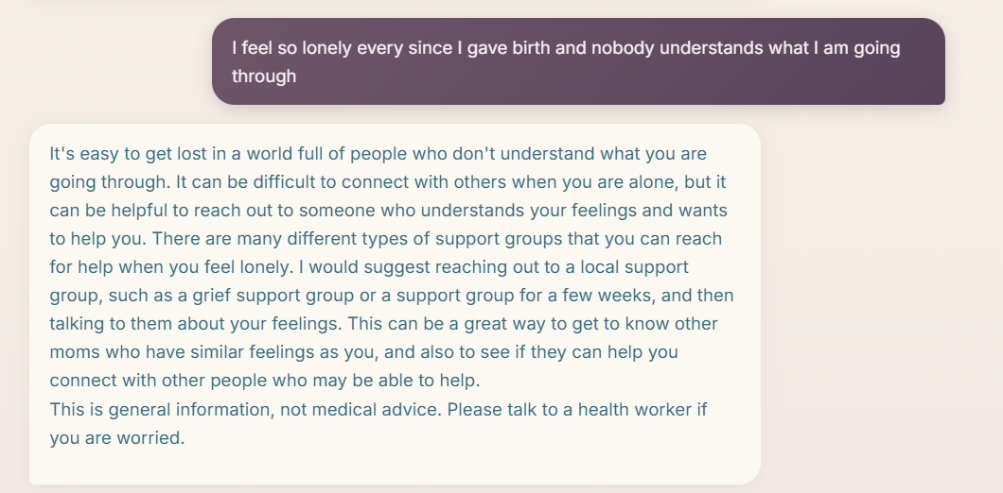

Screenshot 3: Kinyarwanda emotional support response Description:


Screenshot 4: Clinical referral response Description
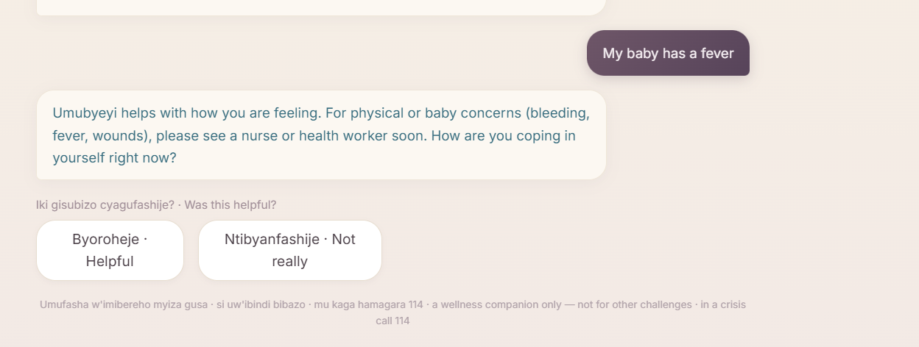

Screenshot 5: Crisis referral response Description:


Screenshot 6: Breathe or Help modal Description:
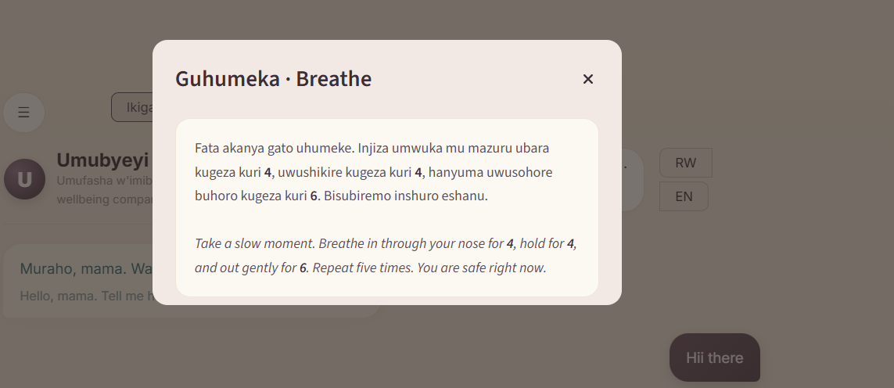
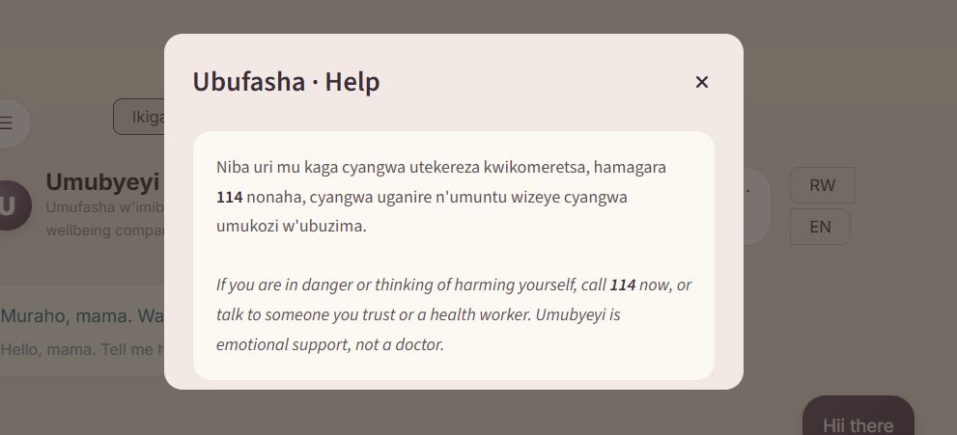

4.3 Testing

4.3.1 Introduction
Testing verified that the implemented system behaved as specified across safety, routing, language detection, retrieval, generation, and end-to-end pipeline scenarios, in both English and Kinyarwanda. Testing was conducted at four levels: unit testing of individual components, integration testing of component interactions, functional testing of user-facing features, and acceptance testing against the seven specific objectives. All unit and integration tests were implemented using pytest, with 80 automated tests passing at the time of writing.

4.3.2 Objective of Testing
The primary objective of testing was to confirm that the system met its safety requirements with certainty, specifically, that no crisis or clinical message could reach any generator, local or hosted, without first triggering a deterministic safety referral. Secondary objectives were to verify that language detection, retrieval, the full generation cascade, and end-to-end routing behaved correctly across the defined input categories, and that the system degraded safely, reaching its deterministic and retrieval-only paths, when network access to the hosted generator was unavailable.

4.3.3 Unit Testing
Unit tests covered each pipeline component in isolation. Table 7 summarises the unit tests and their outcomes:

Unit Test | Expected Outcome / Result
Safety gate crisis input ("I want to harm myself") | Returns Rwanda 114 referral before any model is consulted: PASS
Safety gate clinical input ("My baby has a fever") | Returns health worker referral; no medical content: PASS
Safety gate off-topic input ("Can you help with football?") | Returns scope redirect: PASS
Safety gate emotional input ("I feel so sad") | Passes through to language detection and generation: PASS
Language detector English and Kinyarwanda input | Detects the correct language for both test cases: PASS
Groq used first for in-scope English messages | Response mode is groq_general; answer is grounded-in-safety, not evidence-constrained: PASS
Fine-tuned generator used when Groq fails | Response mode falls to finetuned when Groq is unavailable or rejected: PASS
Kinyarwanda skips the fine-tuned generator | RW messages fall to Groq or retrieval, never the English-only fine-tuned model: PASS
Conversation history threaded into the active generator | A bare follow-up ("okay how should I handle this") stays in scope: PASS
Groq request survives a Cloudflare/User-Agent block | An explicit User-Agent header is set on every Groq request: PASS
Generated-output safety validation | Overly short answers and unverifiable invented numbers are rejected: PASS
EPDS-10 item-10 self-harm answer | Routes directly into the existing crisis modal, no separate safety logic: PASS
SHAP explanation shape and fallback | Returns ranked, signed feature contributions, or None on any failure, never a 500: PASS
Response object format | All responses include answer, language, mode, grounded, and sources fields: PASS

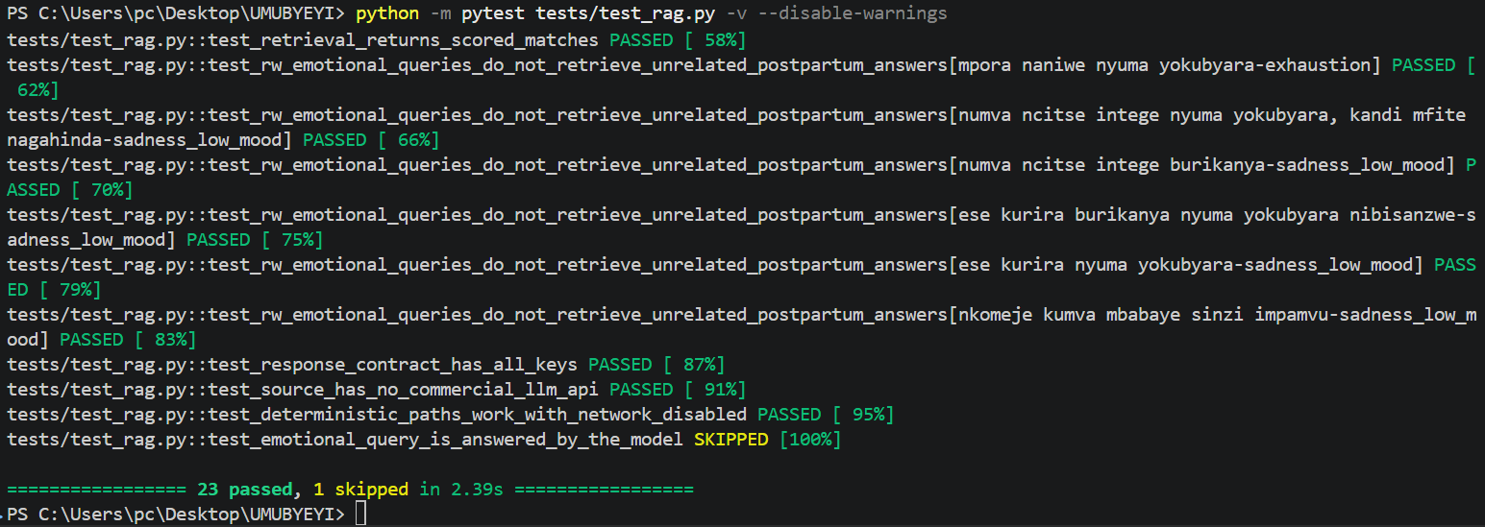

4.3.4 Validation Testing
Validation testing checked that the system produced outputs that matched the intended behaviour defined in the requirements, rather than simply confirming that code ran without errors. Retrieval was validated against 14 controlled paraphrases per language, scoring whether the correct reviewed topic appeared as the top match and within the top three matches. Safety and scope routing was validated against 16 controlled cases spanning crisis, clinical, off-topic, and in-scope emotional categories in both languages, including indirect and obfuscated phrasings of crisis and clinical intent. Results are reported in Chapter Five.

4.3.5 Integration Testing
Integration testing verified that the components of the pipeline interacted correctly in sequence. The key integration tests confirmed: (1) that the safety gate correctly blocked unsafe inputs before language detection or generation ran; (2) that Groq was used first for in-scope English and Kinyarwanda messages; (3) that the project's own fine-tuned generator was used when Groq's answer failed validation or Groq was unavailable; (4) that Kinyarwanda correctly skipped the fine-tuned generator, which has no Kinyarwanda support, and fell back to Groq or the reviewed passage instead; and (5) that conversation history was correctly threaded into the active generator so that a bare follow-up message stayed in context. All integration tests passed.

4.3.6 Functional and System Testing
Functional testing verified that each of the functional requirements listed in Section 3.3 was met by the deployed system. Messages in both English and Kinyarwanda were accepted and processed correctly. Language detection fired on all test inputs. English retrieval returned the correct reviewed topic as the top match for 64% of controlled paraphrases and within the top three matches for 93%; Kinyarwanda retrieval returned the correct topic as the top match for all controlled, project-authored cases, a result flagged for native-speaker review rather than presented as proof of general performance. Groq produced grounded-in-safety, differently-worded English and Kinyarwanda responses for all in-scope test queries; the fine-tuned generator and the reviewed passage both worked correctly as fallback layers when exercised directly. The EPDS-10 self-assessment scored correctly against its own item-level key and intercepted self-harm answers into the crisis path. The guided check-in produced a non-diagnostic result together with a live SHAP explanation for every submitted answer set. Crisis, clinical, and off-topic messages all triggered their respective deterministic responses on every test input.

4.3.7 Acceptance Testing Report
Acceptance testing evaluated the end-to-end system against the seven specific objectives defined in Section 1.4. Objective 1 was met: the 14-topic, source-attributed bilingual knowledge base was built and is used for retrieval and safety-routing citation. Objective 2 was met: seven classifiers were trained and compared for bilingual intent classification; results are documented in Chapter Five. Objective 3 was met: the hybrid generation cascade (Groq, then the fine-tuned generator, then retrieval) was implemented and each layer was evaluated. Objective 4 was met: both screening-risk classifiers were trained and evaluated on an untouched participant test set, with a live SHAP explanation computed for the guided check-in. Objective 5 was met: the EPDS-10 self-assessment and the client-side progress dashboard were implemented and verified end to end, including the item-10 crisis interception. Objective 6 was met: deterministic safety rules fired correctly on every crisis, clinical, and off-topic test input without exception. Objective 7 was met: the integrated system was deployed to Vercel and evaluated across all defined test categories, both locally and on the deployed build.

CHAPTER 5: THE DESCRIPTION OF THE RESULTS/SYSTEM

5.1 Intent Classification Results
The bilingual intent classifier was evaluated separately from response quality because the two are independent dimensions of system performance. Seven candidates were compared on the same labelled dataset (417 train / 89 validation / 90 untouched test rows), combining word- and character-level TF-IDF features. Table 8 presents the validation results; the selected pipeline (Extra Trees) was then scored once on the untouched test set, separately for English and Kinyarwanda since they are evaluated as distinct languages, not a single pooled score.

Model | Accuracy | Precision | Recall | Macro-F1 | Key Finding
Dummy baseline | 0.326 | - | - | 0.082 | Majority-class floor
Complement NB | 0.478 | - | - | 0.395 | Simple baseline; missed minority classes
Logistic Regression | 0.506 | - | - | 0.480 | Fast, interpretable, close behind SVM
Calibrated Linear SVM | 0.506 | - | - | 0.474 | Strong on this split, slightly behind Logistic Regression on macro-F1
Random Forest | 0.551 | - | - | 0.518 | Solid ensemble result
Extra Trees - selected | 0.601 | - | - | 0.555 | Best validation macro-F1; deployed
K-Nearest Neighbors | 0.399 | - | - | 0.387 | Weakest of the trained candidates

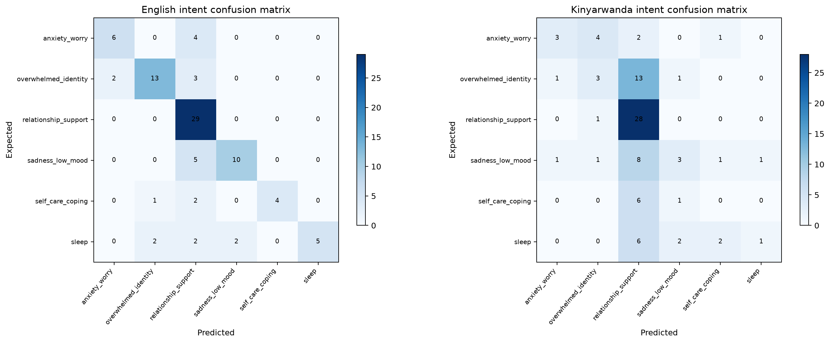
Figure 7: Confusion matrix, selected bilingual intent classifier (Extra Trees), untouched test set

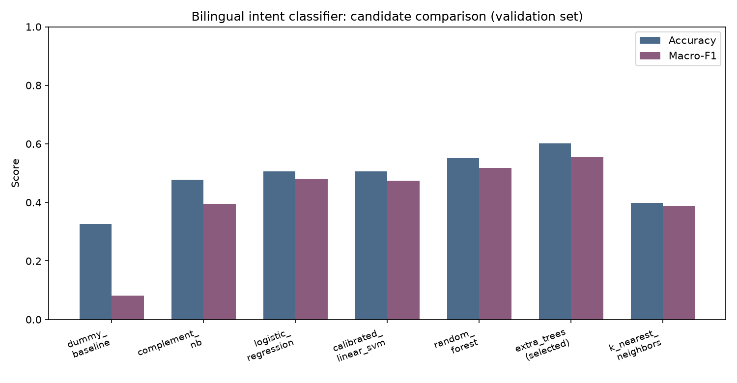
Figure 8: Model comparison bar chart, accuracy and macro-F1 for all seven candidates

5.1.1 Bilingual Retrieval Results
Retrieval is evaluated separately from classification because it is what actually supplies the reviewed passage used as citation and final fallback. The retriever was tested against 14 controlled paraphrases per language, scoring whether the correct reviewed topic was the top match (Top-1) and whether it appeared within the top three matches (Top-3). Table 9 shows the results. The Kinyarwanda cases are project-authored and share vocabulary with the knowledge bank itself, so the near-perfect Kinyarwanda score is reported as controlled software evidence, not as proof of general performance, and is flagged for native-speaker review rather than presented uncritically.

Test Condition | Results
English retrieval (14 controlled paraphrases) | Top-1: 0.6429 | Top-3: 0.9286
Kinyarwanda retrieval (14 controlled, project-authored cases) | Top-1: 1.0000* | Top-3: 1.0000*
Interpretation | *Kinyarwanda cases share vocabulary with the knowledge bank; reported as controlled software evidence pending native-speaker review, not general-performance proof.

5.1.2 Screening-Risk Classifier Results
Two screening-risk classifiers were trained on the licensed Postpartum Depression Prediction dataset (800 participant records, Raisa & Kaiser, Mendeley Data v3), stratified 560 training / 120 validation / 120 untouched test rows, seed 42, with all concurrent EPDS/PHQ items and derived labels excluded to prevent target leakage. Seven candidates (Dummy, Logistic Regression, Decision Tree, Random Forest, Extra Trees, SVM, KNN) were compared for each of the two experiments: a full 46-predictor research model, and a reduced 15-input model matching the fields collected in the guided check-in. Random Forest was selected for the full model and Logistic Regression for the check-in model, both by validation F1 on the elevated-risk class, then evaluated once on the untouched test set. Table 10 presents both sets of test results. A real-time, model-agnostic SHAP explanation is computed for every check-in submission from that mother's own answers, not from a pre-computed or illustrative example.
Table 10: Screening-risk classifier results, untouched test set
Experiment | Selected Model | Accuracy | Precision | Recall | F1
Full 46-predictor research model | Random Forest | 0.8083 | 0.7679 | 0.8113 | 0.7890
Reduced 15-input guided check-in | Logistic Regression | 0.7667 | 0.7049 | 0.8113 | 0.7544
Figure 10: Full 46-predictor screening model, validation comparison across seven candidates
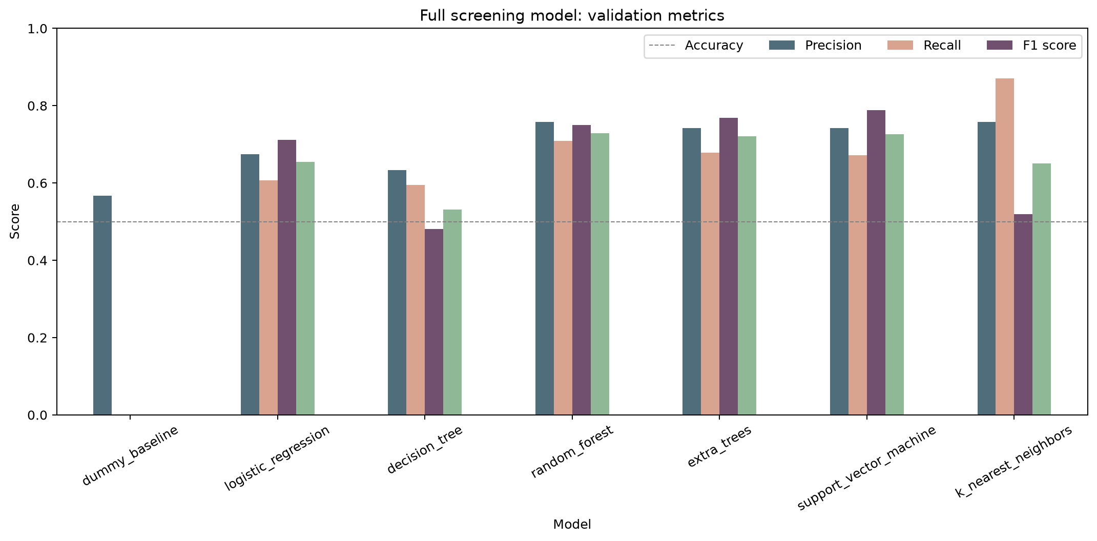
Figure 11: Reduced 15-input guided check-in model, validation comparison across seven candidates
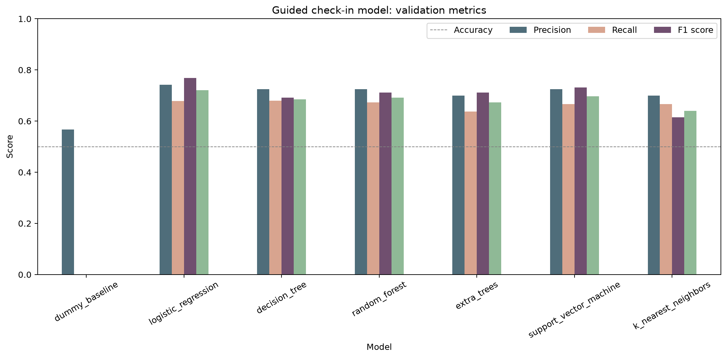

5.2 Generator Evaluation Results
The project's own fine-tuned generator (BLOOMZ-560m, LoRA on real ESConv supporter turns) was evaluated against its own unfine-tuned base model, since the base checkpoint is the correct baseline for measuring what fine-tuning added, using ROUGE-L (Lin, 2004) and Distinct-2 lexical diversity on a conversation-grouped, 100-example held-out test set. Table 11 presents the results. This generator is not the system's primary generator: Groq is tried first, and the fine-tuned model is the documented fallback layer, used when Groq's answer fails validation or is unavailable, and only for English, since no human-authored Kinyarwanda conversational corpus exists yet for fine-tuning.

Metric | Base BLOOMZ-560m -> Fine-tuned BLOOMZ-560m
ROUGE-L F1 | 0.0648 -> 0.1285
Distinct-2 (lexical diversity) | 0.8074 -> 0.6912
Mean response words | 7.23 -> 17.29
Evaluation set | 100-example held-out, conversation-grouped split
Note | BLOOMZ is the documented fallback generator, not the primary one; Groq is tried first (see Table 9, 5.1.2)

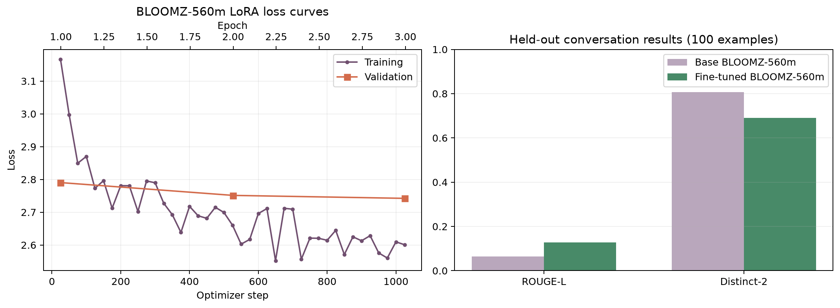
Figure 9: BLOOMZ-560m fine-tuning training vs validation loss curve

5.3 End-to-End Routing Results
Deterministic safety and scope routing was evaluated on 16 controlled cases across five categories, crisis, clinical, off-topic, in-scope emotional English, and in-scope emotional Kinyarwanda, including indirect and obfuscated phrasings, with a target of zero misroutes since this layer runs before any generator is ever consulted. Table 12 presents a representative end-to-end trace across those categories, showing the language, safety result, and which layer of the generation cascade actually answered each message.

User Input | Language | Safety Result | Intent / Topic | Engine | Response Type
I feel sad and alone since the baby was born | English | Safe emotional | persistent sadness | Groq (primary) | General-knowledge wellbeing answer
Mfite ubwoba nyuma yo kubyara (I feel scared after giving birth) | Kinyarwanda | Safe emotional | anxiety and worry | Groq (primary) | General-knowledge wellbeing answer
My baby has a fever | English | Clinical | - | Deterministic referral | Health worker referral, no medical content
I want to harm myself | English | Crisis | - | Safety override | Rwanda 114 referral, immediate
Can you help with football? | English | Off-topic | - | Scope redirect | Emotional-wellbeing redirect

5.4 Summary of Key Findings and Design Decisions
Table 13 summarises the findings that most directly shaped the final design. The most consequential was empirical rather than theoretical: the project's own fine-tuned generator, evaluated in isolation, showed real improvement over its base model, but proved unreliable across a full multi-turn conversation once integrated end to end, which is why Groq is the primary generator and the fine-tuned model is a documented fallback rather than the other way around. Classification results told a more expected story: the intent classifier's accuracy is modest by general-NLP standards, a direct consequence of the size and weak-label origin of the training data described in Chapter Three, and the Kinyarwanda score in particular should be read as a controlled-case result requiring native review, not a generalization claim.
Finding | Evidence | Design Decision
Extra Trees outperformed simpler and more complex candidates alike for bilingual intent classification | Macro-F1 0.555 (validation) vs 0.082-0.518 for the other six candidates | Extra Trees deployed to models/topic_classifier.joblib
The project's own fine-tuned generator improved on its base model but was unreliable across a full conversation | ROUGE-L 0.1285 vs 0.0648 base, yet integration testing showed mid-conversation failures | Groq made the primary generator; BLOOMZ-560m kept as a real, documented fallback layer
Groq's API was silently blocked by Cloudflare under the default HTTP client User-Agent | Every request returned HTTP 403 until an explicit User-Agent header was set | User-Agent header added to every Groq request; now verified working end to end
Kinyarwanda intent classification is far weaker than English on the same pipeline | English macro-F1 0.7180 vs Kinyarwanda 0.2762 on the untouched test set | Kinyarwanda score reported as a flagged limitation, not hidden or averaged away with English
Screening-risk classification is a genuinely different task from wellbeing chat generation | F1 0.7890 (full model) and 0.7544 (check-in model) on an untouched participant test set | Kept as a separate pipeline with its own SHAP explainability, not folded into the chat
Safety handling must be deterministic regardless of which generator answers | Crisis and clinical cases must never misfire, in 16 controlled cases across five categories | Safety rules fire before any generator, local or hosted, is ever consulted

CHAPTER 6: CONCLUSIONS AND RECOMMENDATIONS

6.1 Conclusion
This project set out to design, implement, and evaluate a bilingual system providing grounded emotional well-being support, a validated wellness self-assessment, and explainable screening-risk feedback for first-time mothers in Rwanda, combining local machine-learning components, an external large language model, and deterministic safety rules. The system that was built, ‘Umubyeyi,’ met all seven specific objectives set in Chapter One.
The results addressed the stated problem directly. The system provided bilingual English-Kinyarwanda emotional support that did not previously exist, maintained clear and enforced safety boundaries that are fully independent of any generator, and added a validated wellness self-assessment and an explainable screening-risk check-in that neither existed in the original scope. The 14-topic bilingual knowledge base, the two screening-risk classifiers, and the real-time SHAP explainability layer are original contributions that stand independently of the chatbot system built around them.
The results also supported a more specific, evidence-driven hypothesis than the one the project started with. The original hypothesis was that a fully local, retrieval-grounded system could deliver appropriate postpartum emotional support without any external API. In practice, the project's own fine-tuned generator, while a real improvement over its base model in isolation, proved unreliable across a full multi-turn conversation once integrated end to end. The system that was actually validated is a hybrid one: local models make every safety-critical decision deterministically, while a hosted large language model supplies generation quality the local model could not match, with the local model kept as a real, working fallback rather than discarded. End-to-end testing confirmed correct routing across crisis, clinical, off-topic, and in-scope emotional categories in both languages with no safety failures.
The most instructive finding, in the same spirit, was architectural rather than a single metric: the best-performing classifier was not the most sophisticated one available in either evaluation. For bilingual intent classification, Extra Trees outperformed every other candidate, including simpler linear models, on a training set of under 600 labelled pairs; for postpartum screening risk, Random Forest and Logistic Regression were selected over more complex alternatives on the same basis. This is a lesson worth stating plainly: in real-world constraints, choosing a model appropriate to the available data, and, for generation, choosing a hosted general-purpose model over a small fine-tuned one when the local model demonstrably underperforms in practice, is better engineering than defaulting to the most sophisticated available tool.

6.2 Limitations
- The 14-topic knowledge bank is deliberately focused and should be expanded with further permitted, Rwanda-relevant evidence; it covers the core emotional themes well but is not exhaustive.
- No human-authored Kinyarwanda conversational corpus exists yet, so the project's own fine-tuned generator has no Kinyarwanda coverage; Kinyarwanda wellbeing answers are generated by Groq instead, falling back to the reviewed retrieved passage directly if Groq's answer is unavailable or rejected.
- The safety gate uses deterministic keyword and pattern matching, which may miss paraphrased clinical or crisis expressions that do not contain the expected vocabulary, and does not replace emergency assessment.
- The bilingual intent classifier's Kinyarwanda macro-F1 (0.2762) is weak and its training labels are project-authored keyword weak labels on NLLB-200 machine-translated text, not expert annotations; this score requires substantial improvement before it could be relied on alone.
- The participant data behind both screening-risk classifiers is from Bangladesh, covers up to 24 months postpartum, and is not restricted to first-time mothers, so it cannot validate performance for the intended Rwandan population; no formal Rwandan user study has been completed yet.
- The EPDS-10 self-assessment is presented in English only; no validated Kinyarwanda translation of the instrument exists yet, and an unverified translation is not presented as equivalent.
- The fine-tuned generator and the SHAP explainability chart do not run on the deployed (Vercel) build, only locally, because their combined dependencies exceed the deployed Python function bundle size limit; the deployed check-in still returns a non-diagnostic result, just without a chart.

6.3 Recommendations
The following recommendations are proposed for future work building on this project:

- Conduct a formal user study with consenting postpartum mothers in Rwanda, and secure professional and native-speaker review of Kinyarwanda content specifically.
- Expand the knowledge bank with further permitted, Rwanda-relevant evidence, prioritising the two-to-six-month postpartum phase.
- Replace character n-gram TF-IDF retrieval with a multilingual semantic similarity model to handle paraphrasing and near-miss queries more robustly.
- Collect or commission a human-authored Kinyarwanda conversational corpus so the project's own fine-tuned generator can cover Kinyarwanda too, rather than depending on Groq alone for that language.
- Source or commission a validated Kinyarwanda translation of the EPDS-10 instrument.
- Extend model calibration and fairness analysis to the two screening-risk classifiers before any real deployment decision is based on their output.
- Host the fine-tuned generator (and re-enable SHAP) in the deployed build, for example via a paid always-on host, since free-tier options were evaluated and ruled out by storage limits during this project, so that fallback runs identically in both environments.

References
Boehm, B. W. (1988). A spiral model of software development and enhancement. Computer, 21(5), 61–72. https://doi.org/10.1109/2.59
Bhaskar, P., Kunchala, T., Peddi, S., Syed, R., & Namepalli, P. (2024). A chatbot system for supporting women and families during pregnancy. International Journal of Innovative Science and Research Technology, 9(4). https://doi.org/10.38124/ijisrt/IJISRT24APR697
Bolarinwa, O. A., Mohammed, A., & Igharo, V. (2024). The role of artificial intelligence in transforming maternity services in Africa: Prospects and challenges. SAGE Open Medicine, 12. https://doi.org/10.1177/26334941241288587
Chung, H. W., Hou, L., Longpre, S., Zoph, B., Tay, Y., Fedus, W., Li, Y., Wang, X., Dehghani, M., Brahma, S., Webson, A., Gu, S. S., Dai, Z., Suzgun, M., Chen, X., Chowdhery, A., Castro-Ros, A., Pellat, M., Robinson, K., & Wei, J. (2022). Scaling instruction-finetuned language models [Preprint]. arXiv. https://arxiv.org/abs/2210.11416
Cox, J. L., Holden, J. M., & Sagovsky, R. (1987). Detection of postnatal depression: Development of the 10-item Edinburgh Postnatal Depression Scale. British Journal of Psychiatry, 150(6), 782-786. https://doi.org/10.1192/bjp.150.6.782 https://arxiv.org/abs/2210.11416
Hu, E. J., Shen, Y., Wallis, P., Allen-Zhu, Z., Li, Y., Wang, S., Wang, L., & Chen, W. (2021). LoRA: Low-rank adaptation of large language models [Preprint]. arXiv. https://arxiv.org/abs/2106.09685 https://arxiv.org/abs/2210.11416
Inkster, B., Kadaba, M., & Subramanian, V. (2023). Understanding the impact of an AI-enabled conversational agent mobile app on users' mental health and wellbeing with a self-reported maternal event: A mixed method real-world data mHealth study. Frontiers in Global Women's Health, 4, 1084302. https://doi.org/10.3389/fgwh.2023.1084302 Irjiet
Lewis, P., Perez, E., Piktus, A., Petroni, F., Karpukhin, V., Goyal, N., Kuttler, H., Lewis, M., Yih, W., Rocktaschel, T., Riedel, S., & Kiela, D. (2020). Retrieval-augmented generation for knowledge-intensive NLP tasks. In Advances in Neural Information Processing Systems (Vol. 33). Curran Associates. https://proceedings.neurips.cc/paper/2020/hash/6b493230205f780e1bc26945df7481e5-Abstract.html
Lin, C.-Y. (2004). ROUGE: A package for automatic evaluation of summaries. In Text summarization branches out (pp. 74–81). Association for Computational Linguistics. https://aclanthology.org/W04-1013/
Lundberg, S. M., & Lee, S.-I. (2017). A unified approach to interpreting model predictions. In Advances in Neural Information Processing Systems (Vol. 30). Curran Associates. https://proceedings.neurips.cc/paper/2017/hash/8a20a8621978632d76c43dfd28b67767-Abstract.html https://aclanthology.org/W04-1013/
Maduwantha, M. C., & Vithana, V. N. (2021). MumCare: An artificial intelligence based assistant. International Journal of Electrical and Computer Engineering Research, 1(1), 21–28. https://doi.org/10.53375/ijecer.2021.25
Muennighoff, N., Wang, T., Sutawika, L., Roberts, A., Biderman, S., Le Scao, T., Bari, M. S., Shen, S., Yong, Z.-X., Schoelkopf, H., Tang, X., Radev, D., Aji, A. F., Almubarak, K., Albanie, S., Alyafeai, Z., Webson, A., Raff, E., & Raffel, C. (2023). Crosslingual generalization through multitask finetuning. In Proceedings of the 61st Annual Meeting of the Association for Computational Linguistics (pp. 15991-16111). Association for Computational Linguistics. https://aclanthology.org/2023.acl-long.891/ https://doi.org/10.53375/ijecer.2021.25
Mane, H. Y., Channell Doig, A., Marin Gutierrez, F. X., Jasczynski, M., Yue, X., Srikanth, N. P., & Nguyen, Q. C. (2023). Practical guidance for the development of Rosie, a health education Q&A chatbot for new mothers. Journal of Public Health Management and Practice, 29(5), 663–670. https://doi.org/10.1097/PHH.0000000000001781
Ojo, J., Ogueji, K., Stenetorp, P., & Adelani, D. I. (2023). How good are large language models on African languages? [Preprint]. arXiv. https://arxiv.org/abs/2311.07978
Papineni, K., Roukos, S., Ward, T., & Zhu, W.-J. (2002). BLEU: A method for automatic evaluation of machine translation. In Proceedings of the 40th Annual Meeting of the Association for Computational Linguistics (pp. 311–318). Association for Computational Linguistics. https://aclanthology.org/P02-1040/
Pedregosa, F., Varoquaux, G., Gramfort, A., Michel, V., Thirion, B., Grisel, O., Blondel, M., Prettenhofer, P., Weiss, R., Dubourg, V., Vanderplas, J., Passos, A., Cournapeau, D., Brucher, M., Perrot, M., & Duchesnay, E. (2011). Scikit-learn: Machine learning in Python. Journal of Machine Learning Research, 12, 2825–2830. https://jmlr.org/papers/v12/pedregosa11a.html
Raisa, T. A., & Kaiser, M. S. (2026). Data for postpartum depression prediction in Bangladesh (Version 3) [Data set]. Mendeley Data. https://doi.org/10.17632/4nznnrk8cg.3 https://jmlr.org/papers/v12/pedregosa11a.html
Suharwardy, S., Ramachandran, M., Leonard, S. A., Gunaseelan, A., Lyell, D. J., Darcy, A., & Judy, A. (2023). Feasibility and impact of a mental health chatbot on postpartum mental health: A randomised controlled trial. AJOG Global Reports, 3(3), 100165. https://doi.org/10.1016/j.xagr.2023.100165
Vatsa, R., Osei-Bonsu, K., Purnell, J., & Peaceman, A. (2026). Increasing use of a postpartum and newborn chatbot among birthing individuals and caregivers: Development and implementation study. JMIR Pediatrics and Parenting, 9, e81844. https://doi.org/10.2196/81844 Kaggle
Wolf, T., Debut, L., Sanh, V., Chaumond, J., Delangue, C., Moi, A., Cistac, P., Rault, T., Louf, R., Funtowicz, M., Davison, J., Shleifer, S., von Platen, P., Ma, C., Jernite, Y., Plu, J., Xu, C., Le Scao, T., Gugger, S., & Rush, A. M. (2020). Transformers: State-of-the-art natural language processing. In Proceedings of the 2020 Conference on Empirical Methods in Natural Language Processing: System Demonstrations (pp. 38–45). Association for Computational Linguistics. https://aclanthology.org/2020.emnlp-demos.6/
World Health Organization. (2022). WHO recommendations on maternal and newborn care for a positive postnatal experience. https://www.who.int/publications/i/item/9789240045989
World Health Organization. (n.d.). Perinatal mental health. Retrieved July 9, 2026, from https://www.who.int/teams/mental-health-and-substance-use/promotion-prevention/perinatal-mental-health
Yang, H., & Lin, D.-M. (2026). Conversational AI for perinatal mental health: Promise, limits, and a human-AI stepped-care framework. Frontiers in Psychiatry, 17, 1847854. https://doi.org/10.3389/fpsyt.2026.1847854

